Laptop Price Predictor Using Machine Learning

# Md. Mashrur Jamil Rafin

*Dept. of ECE North South University*

Dhaka, Bangladesh [mashrur](mailto:mashrur.jamil@northsouth.edu)[.jamil@northsouth.edu](mailto:.jamil@northsouth.edu)

# Rahemul Islam

*Dept. of ECE North South University*

Dhaka, Bangladesh [rahemul.islam@northsouth.edu](mailto:rahemul.islam@northsouth.edu)

# Mahfuj Ahmed Jim

*Dept. of ECE North South University*

Dhaka, Bangladesh [mahfuj.jim@northsouth.edu](mailto:mahfuj.jim@northsouth.edu)

***Abstract*—Now a days, laptop market is competitive as major companies are adopting technological advances. So, it is not uncommon to find laptops incorrectly priced at retail and online stores. This paper presents a Laptop price predictor system using the supervised machine learning technique. ‘Laptop Price Predictor’ provides a tentative price of laptop according to the user configurations. As this is a regression problem, we have applied Linear Regression, K-Nearest Neighbors, Decision Tree, Random Forest and Support Vector Machine in our dataset and achieved highest R2 score (86%) and lowest MAE, MSE values in Random Forest. With the help of our project, user will be able to understand the pricing of laptop market according to their specifications.**

INTRODUCTION

Laptop has become one of the most essential and used items in our daily life. With the overwhelming amount of specifications and brand names on the market, it becomes difficult for customers to pick their laptop. The laptop market has accelerated due to increased demands of ‘work from home’ and ‘learn from home’ because of recent pandemic situation. It is not uncommon to find laptops incorrectly priced at retail stores and online. Laptop price usually depends on many features such as availability, region, release year etc. However, most significant ones are Brand, Type, RAM, ROM, GPU, CPU, Display Type, Touch Screen etc. This machine learning project will help the consumer to understand the laptop market pricing. It will be and end-to-end product. Our targeted users are: consumers with a limited budget, such as students. With the help of our model, they will be able to predict the price of the laptop according to the features and configurations that they want. In this project, we have applied different machine learning methods and techniques in order to achieve higher precision in laptop price prediction.

CONTRIBUTION

Our contribution of the paper is as follows:

*I. Software Architectural Diagram*

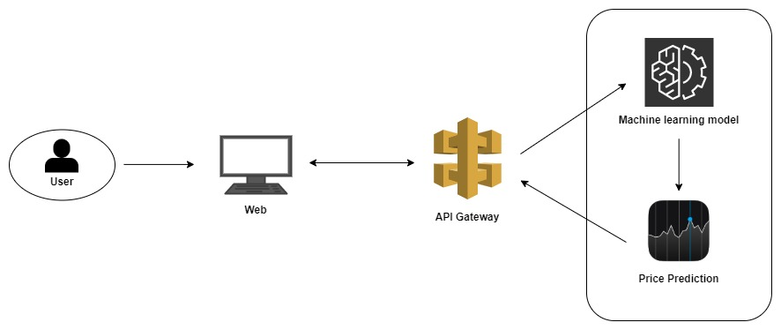

Fig. 1. Software Architectural Diagram

*II. Explanatory Data Analysis (EDA) Visualization*

RESULT

Laptop has become one of the most essential and used items in our daily life.

DEPLOYMENT

Laptop has become one of the most essential and used items in our daily life.

CONCLUSION

At present days, Laptop has become part of our daily human life and also laptop market is very competitive as top brands are embracing technological advances. As a result, it is not uncommon for laptop prices to be incorrect in online and retail shops. With the overwhelming amount of specifications and brand names on the market, it becomes difficult for customers to choose their laptop. INCOMPLETE